NAME:R.KALYAN KUMAR REDDY REGNO:192472274

COURSE CODE:CSA 0504

EX. No. 1 – DDL Commands using CREATE, ALTER, TRUNCATE, and DROP

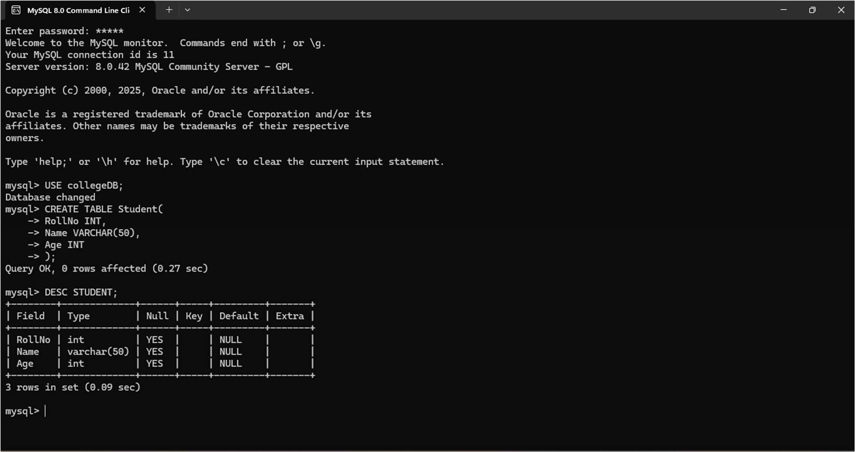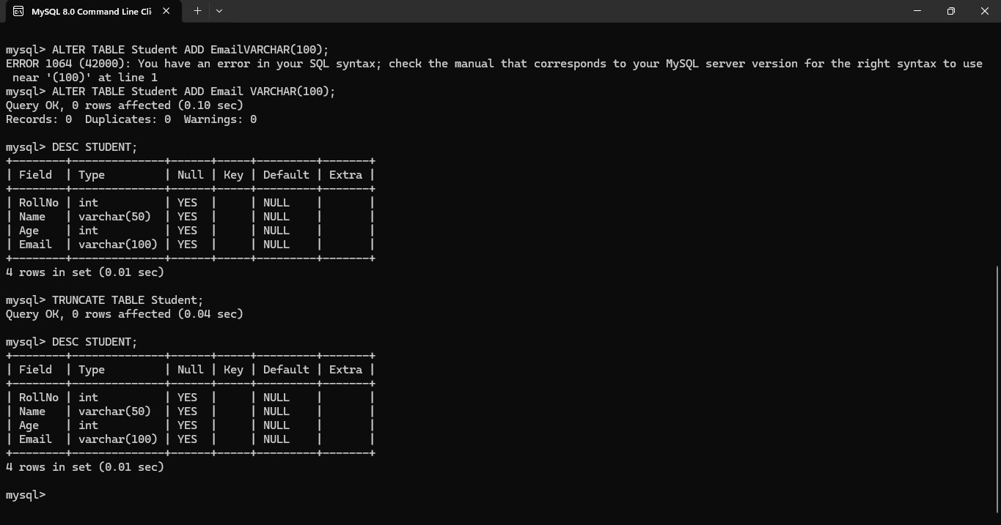



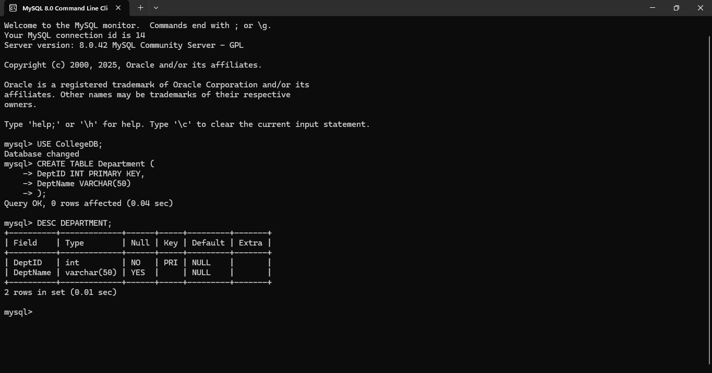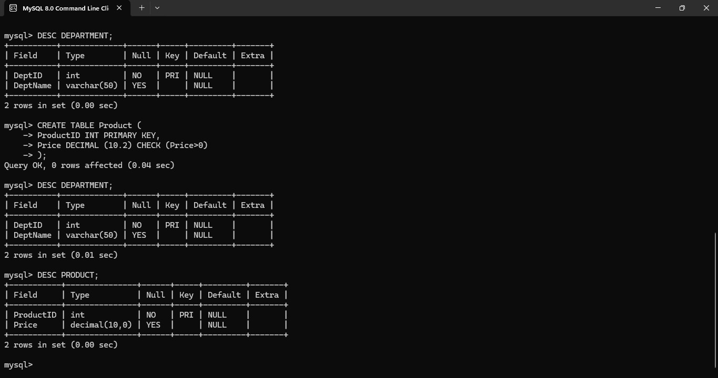EX. No. 2 – DDL Commands with Constraints

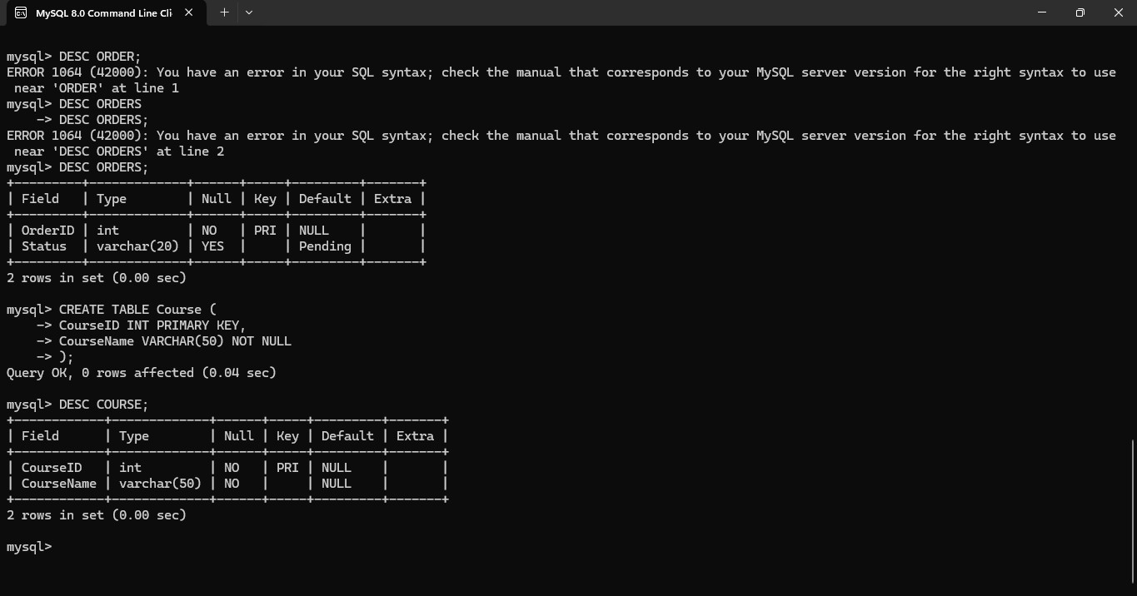

EX 3 DML Commands using INSERT and SELECT

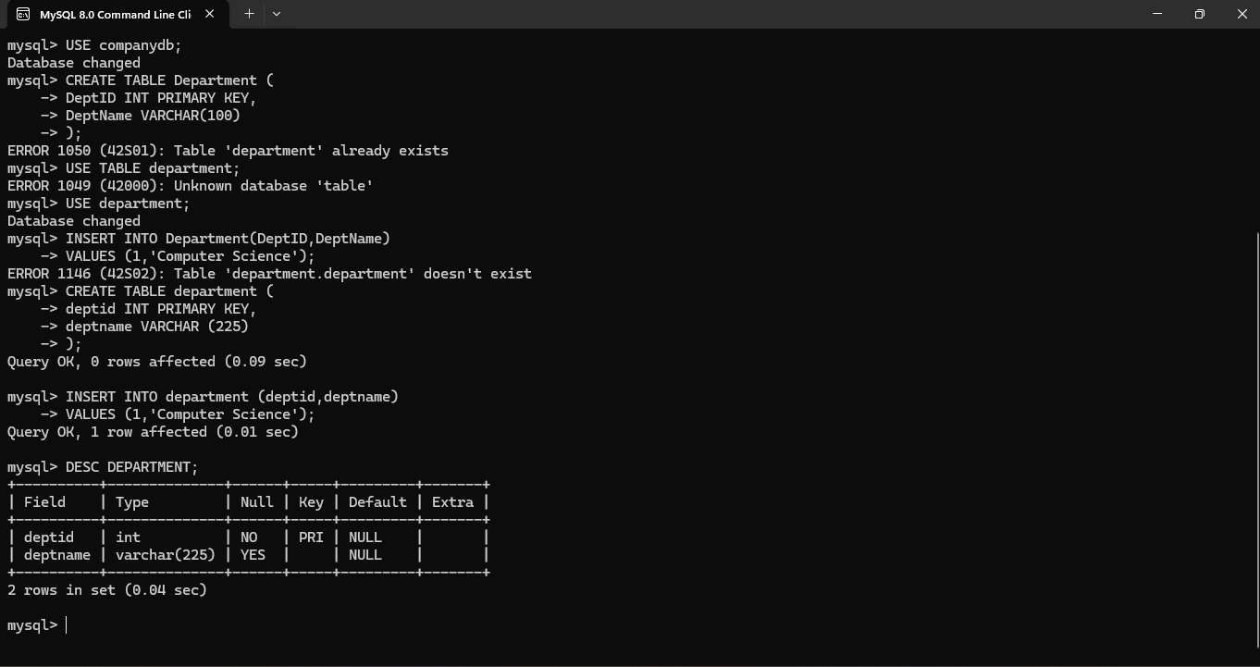

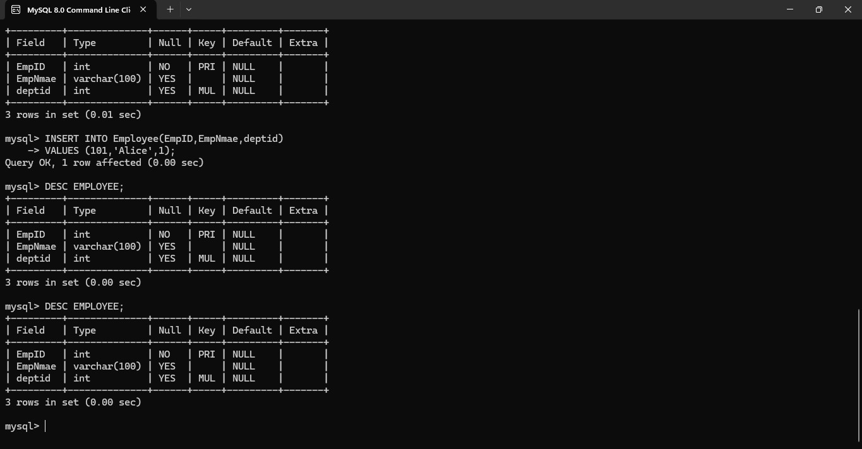

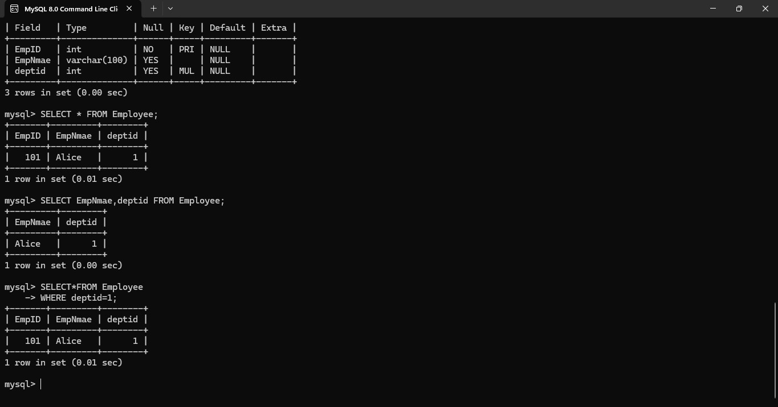

EX. No. 4 – DML Commands using UPDATE and DELETE

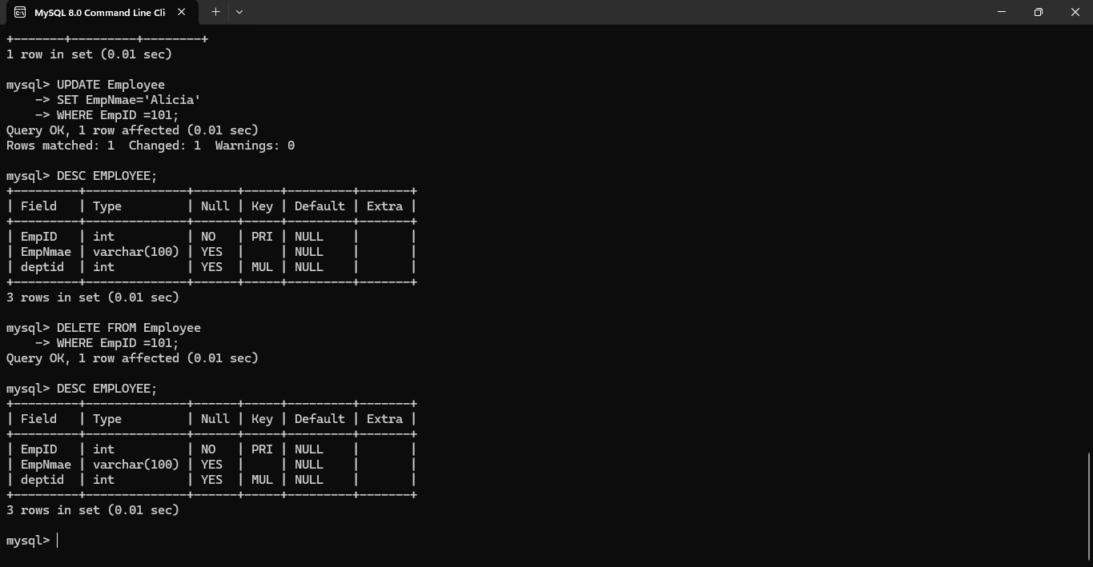

EX. No. 5 – TCL Commands: COMMIT, SAVEPOINT, ROLLBACK

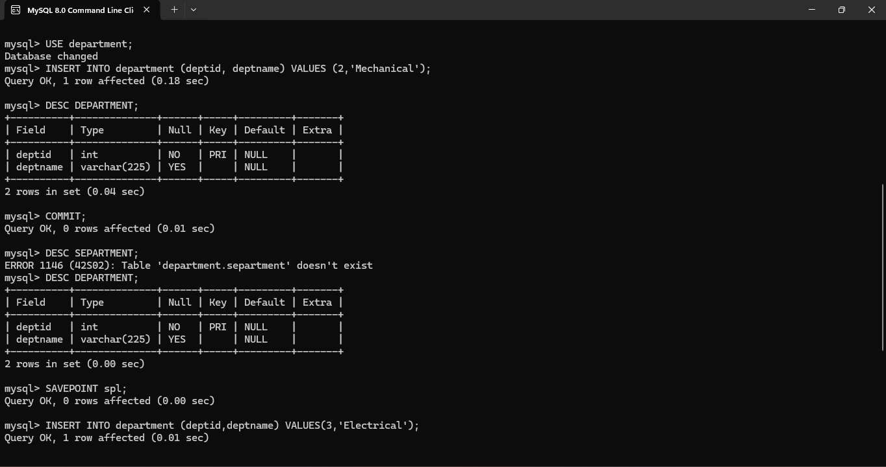

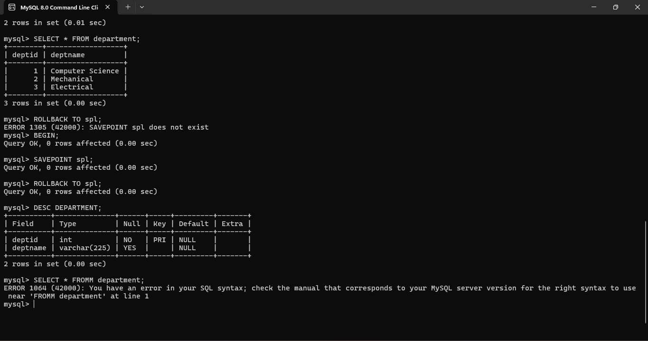

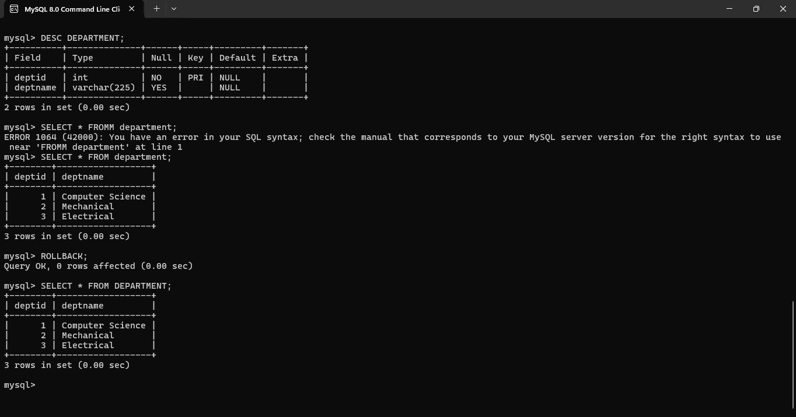

EX. No. 6 – DCL Commands: GRANT and REVOKE

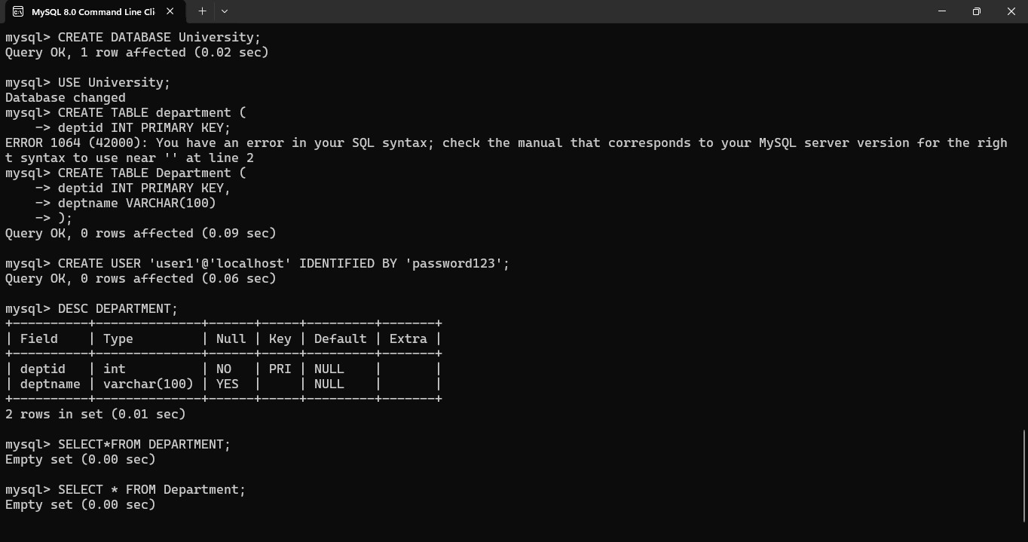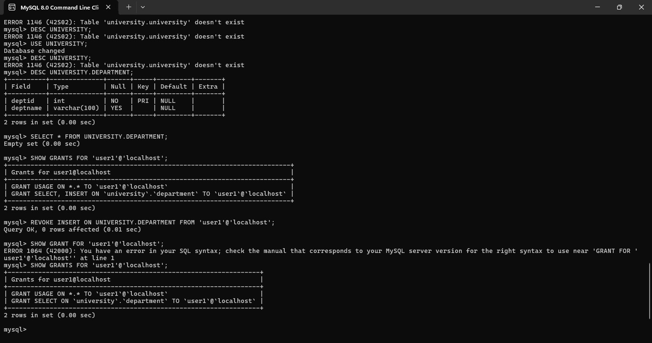

EX. No. 7 – SELECT with Various Clauses: WHERE, Pattern Matching

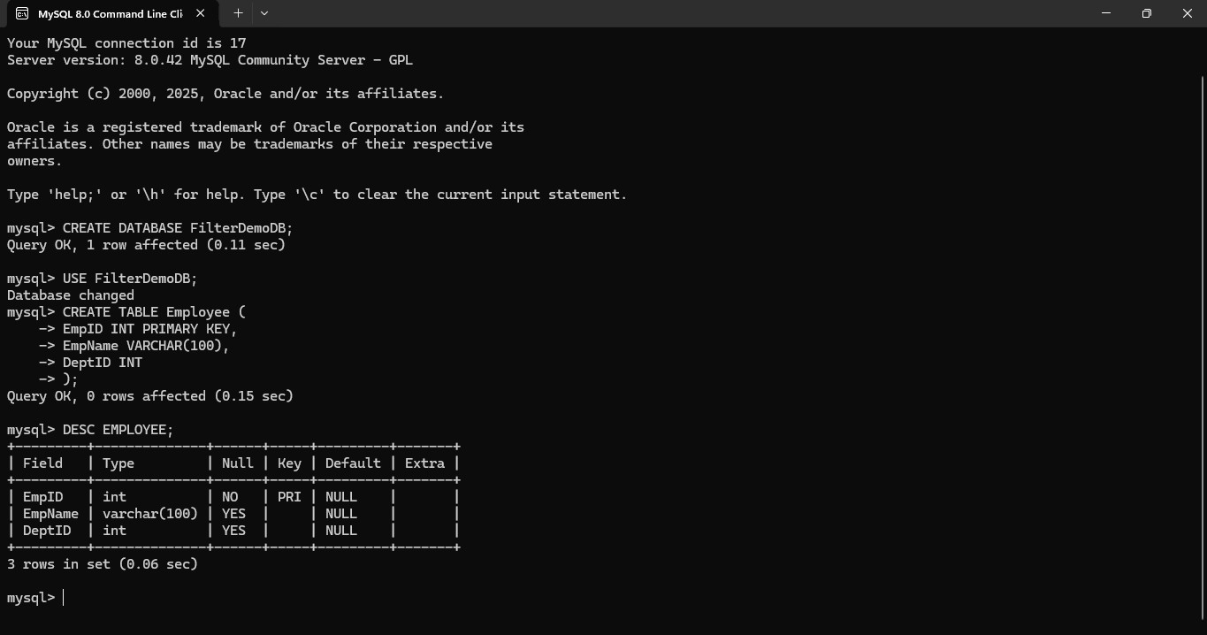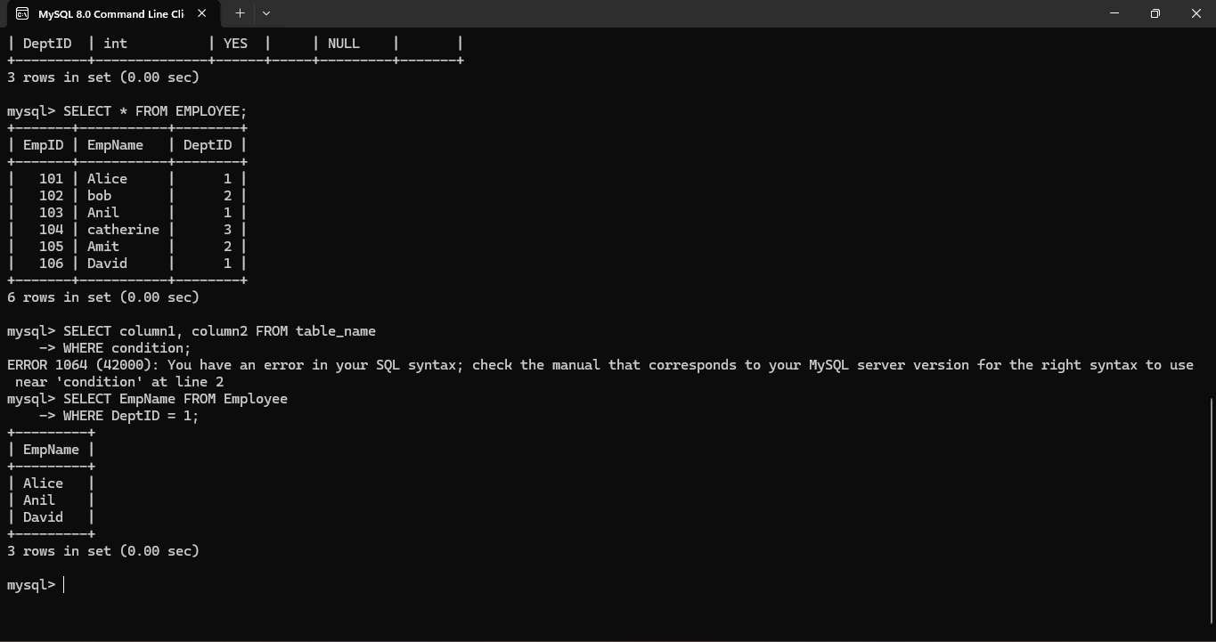

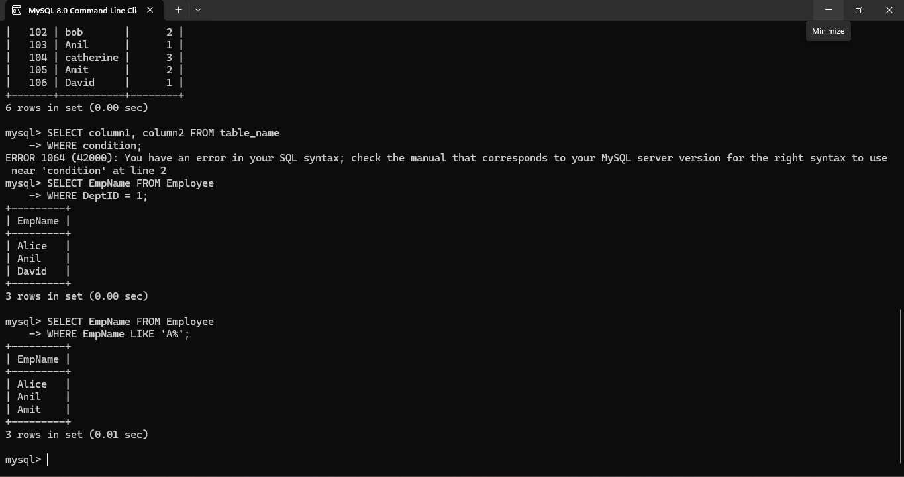

EX 8 SELECT with Various Clauses: BETWEEN, IN, Aggregate Function

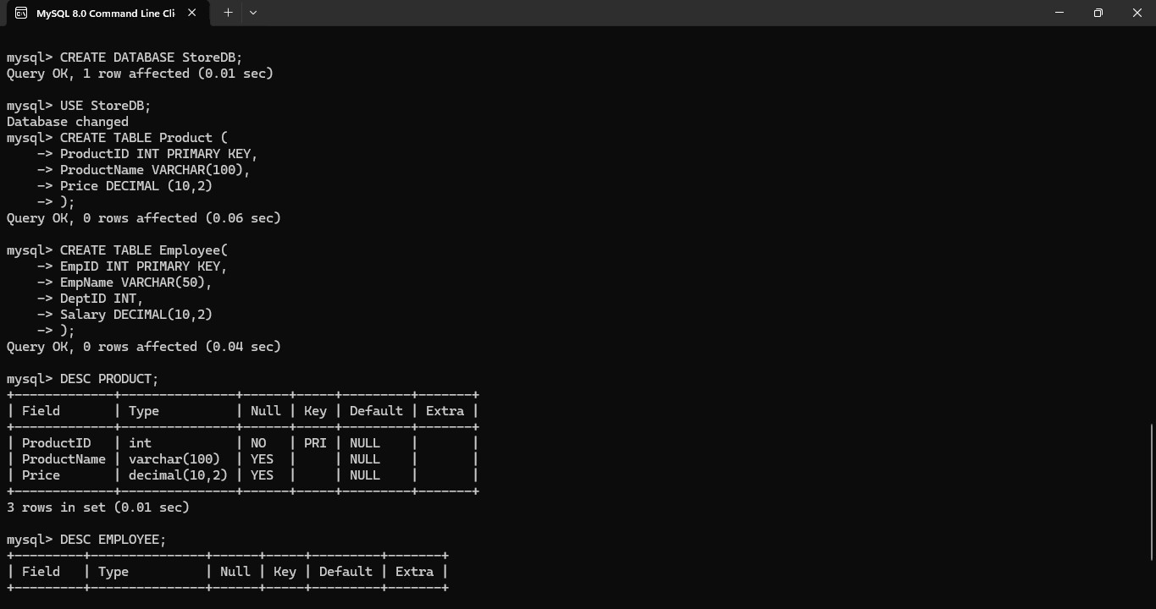

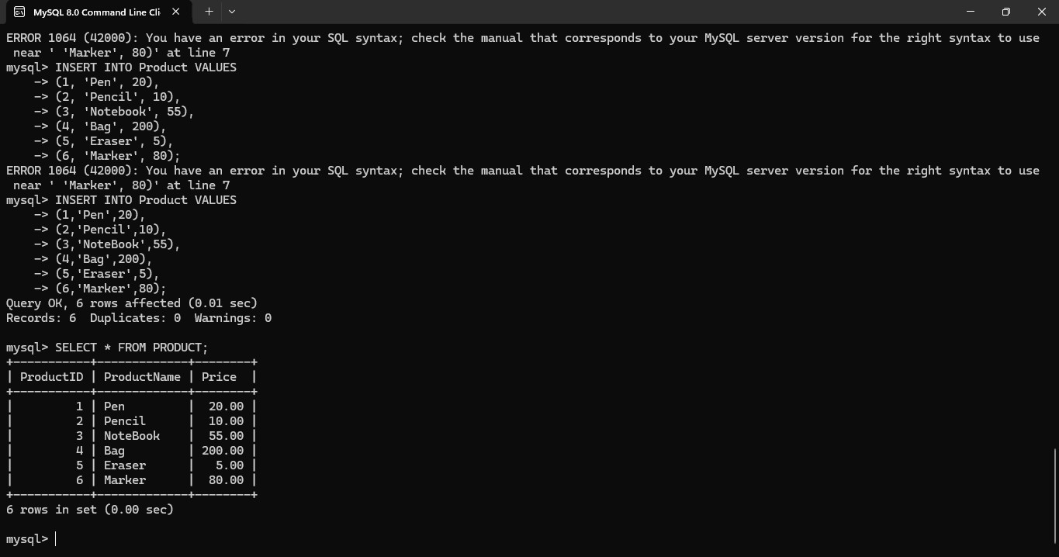

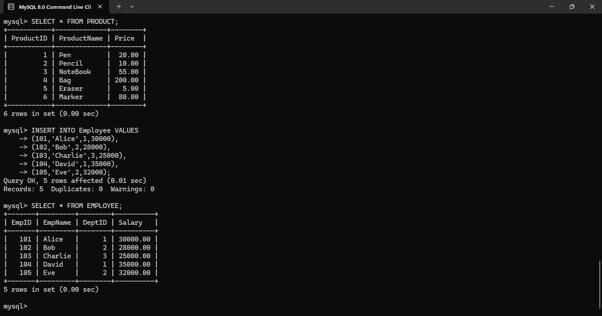

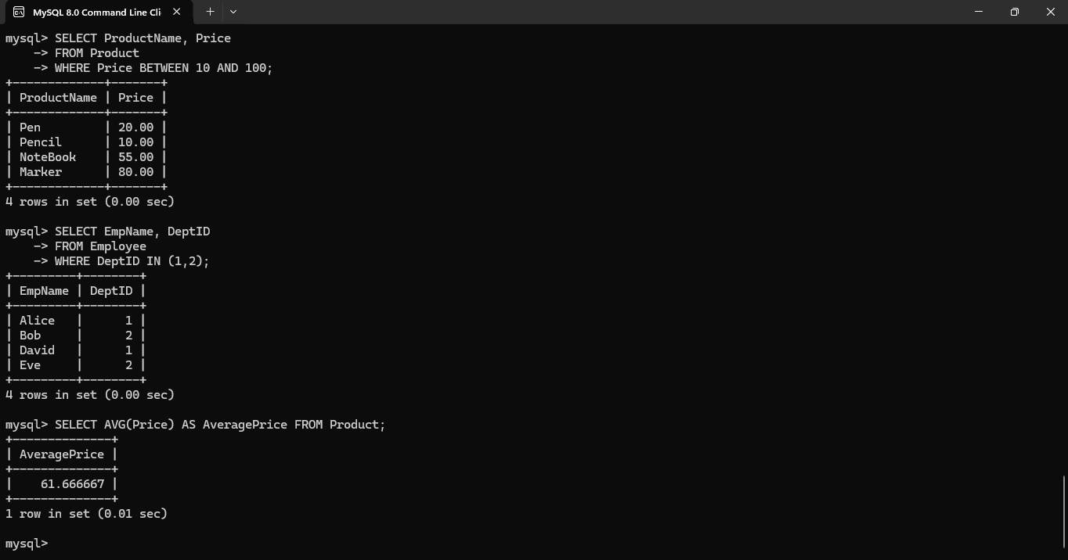

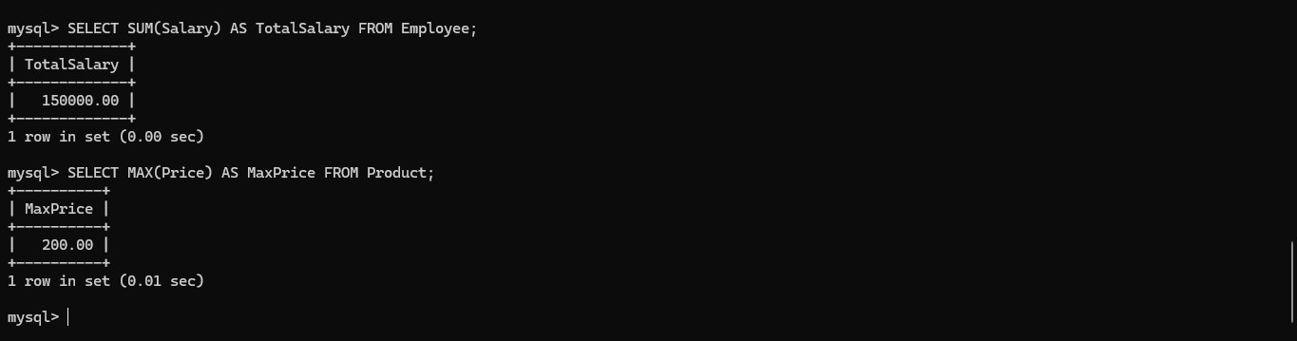

EX. No. 9 – SELECT with Various Clauses: GROUP BY, HAVING, ORDER BY

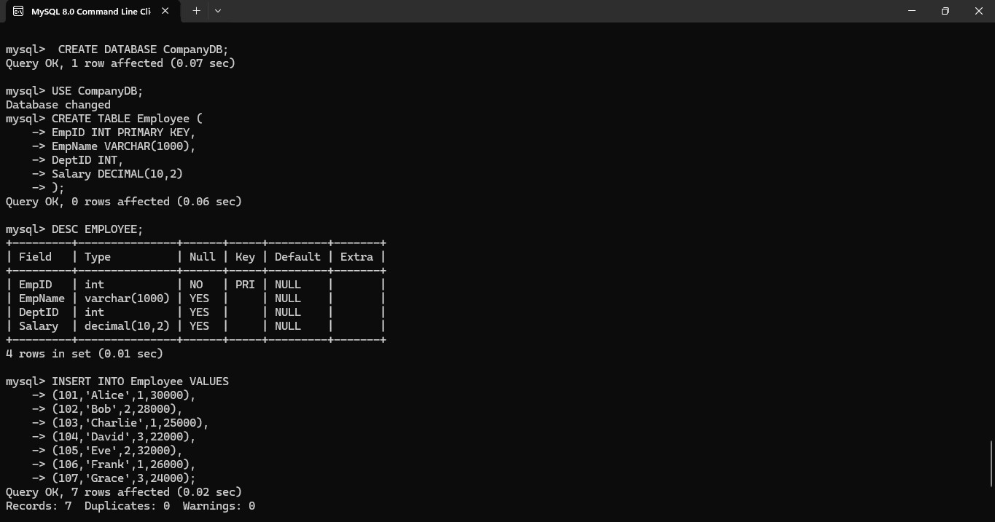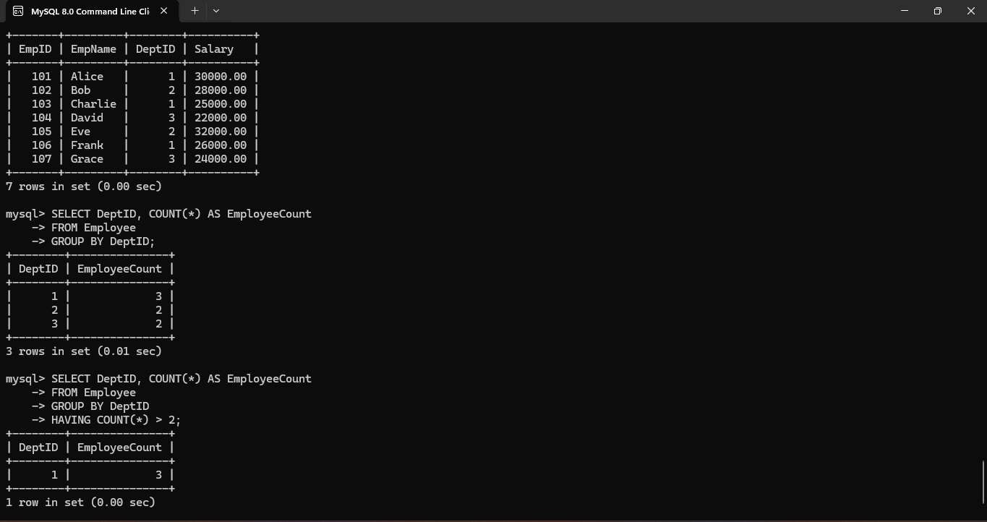

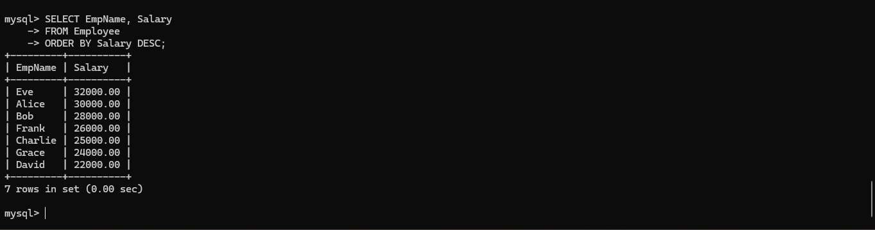

EX. No. 10 – Query with Subquery and Correlated Query

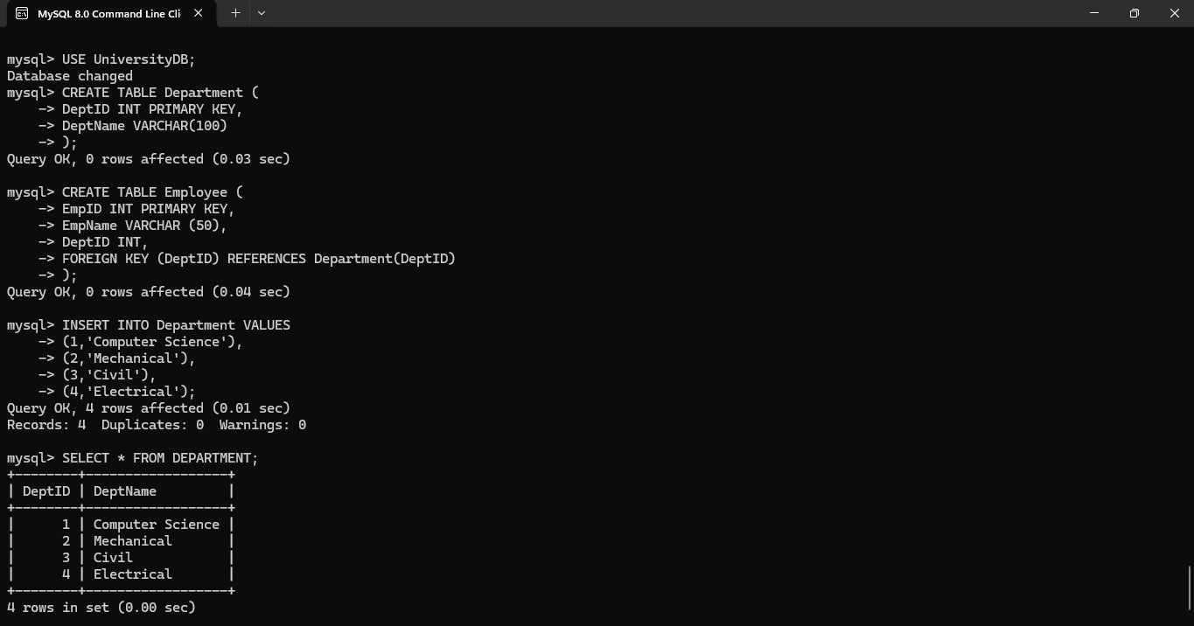

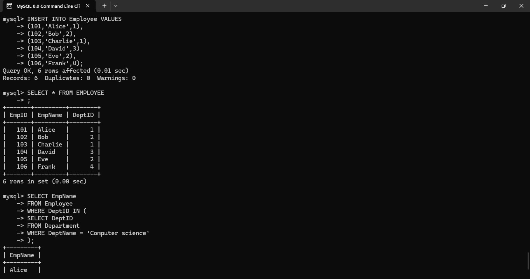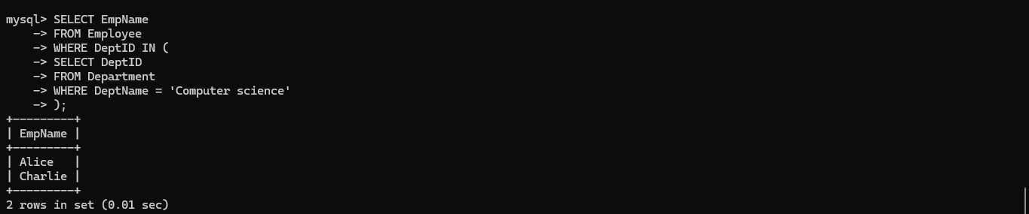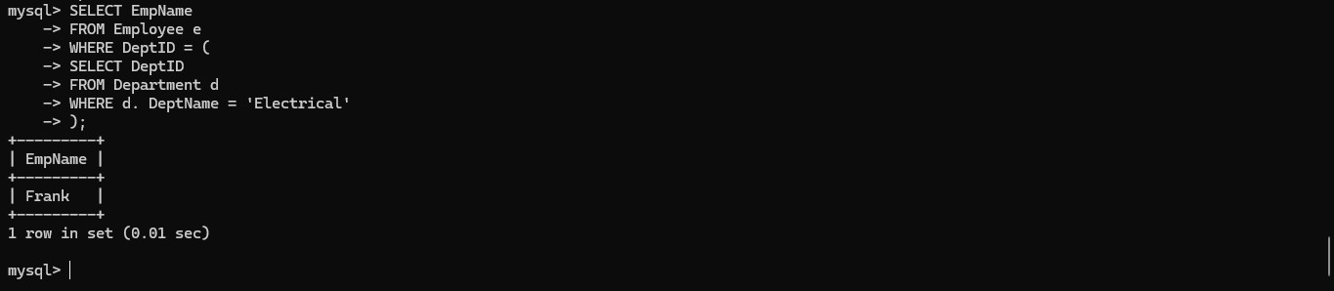

EX. No. 11 – Query with Joins: EquiJoin, InnerJoin, OuterJoin

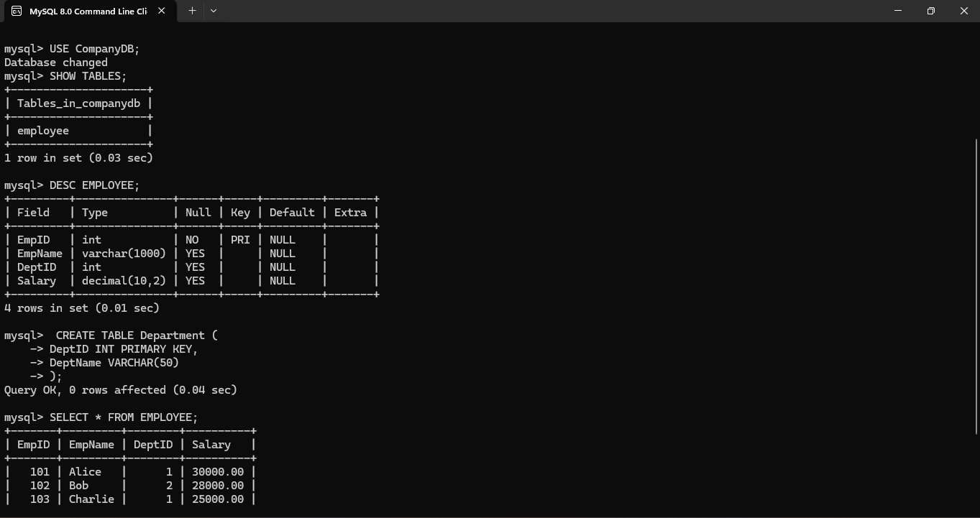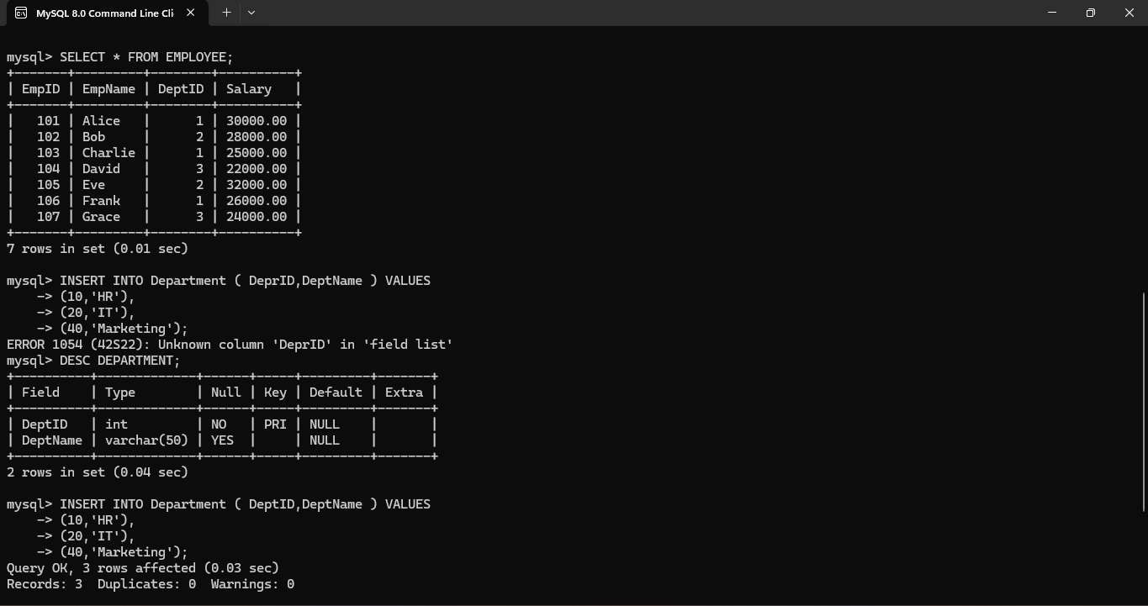

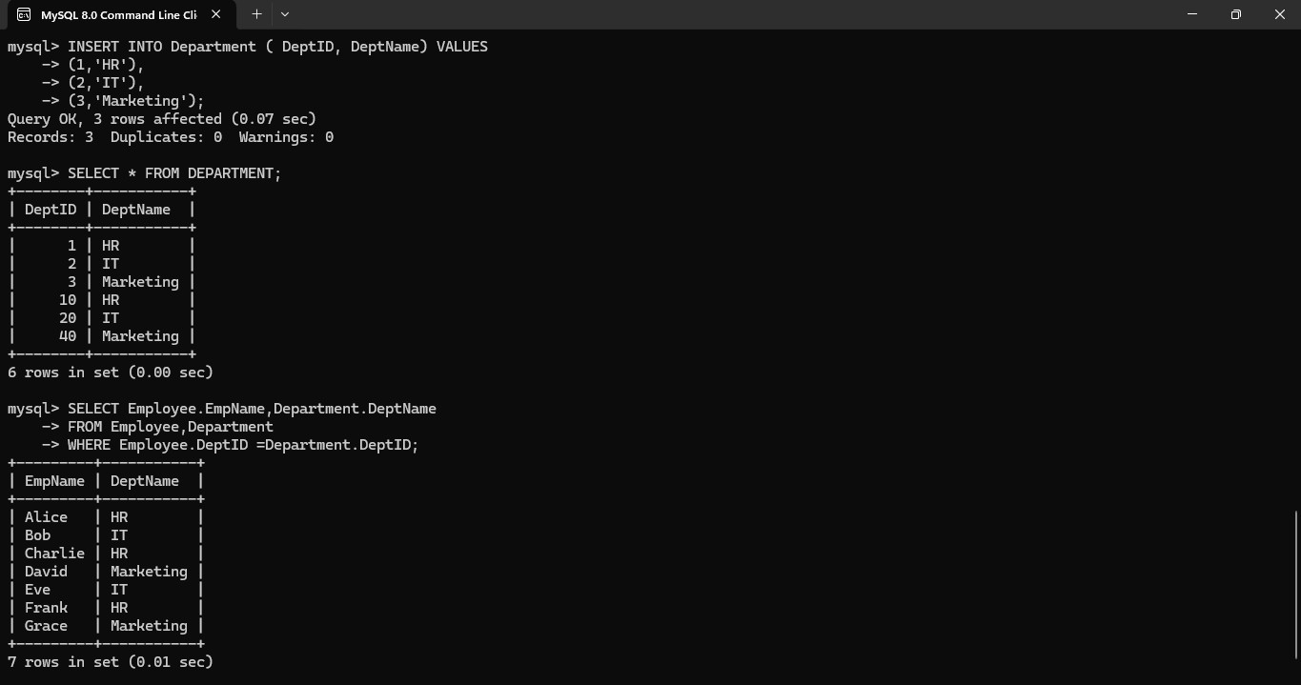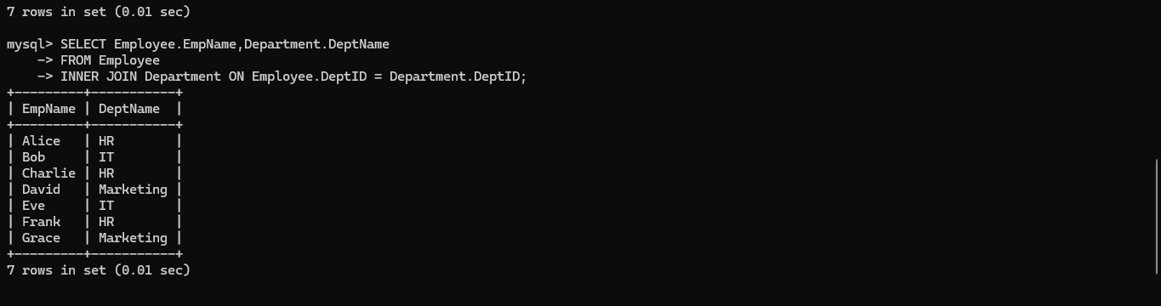

EX. No. 12 – Query with VIEW and INDEX

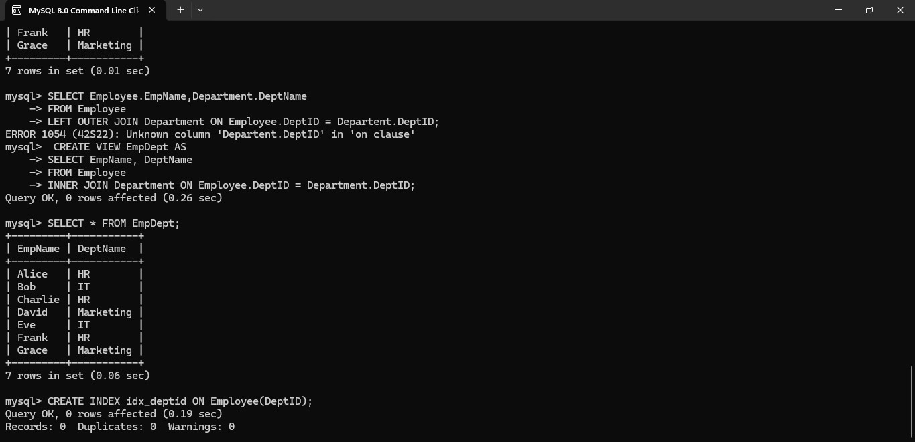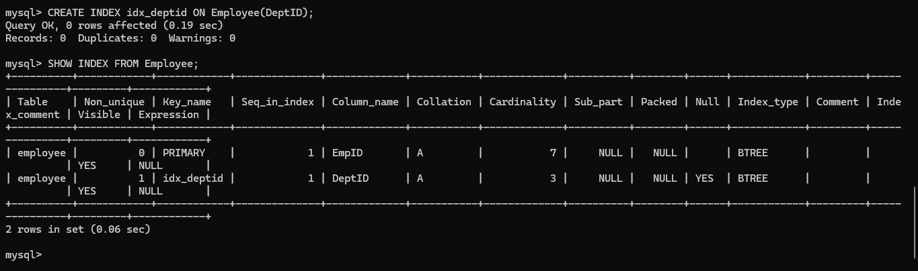

EX. No. 13 – Query with AUTO_INCREMENT SEQUENCES

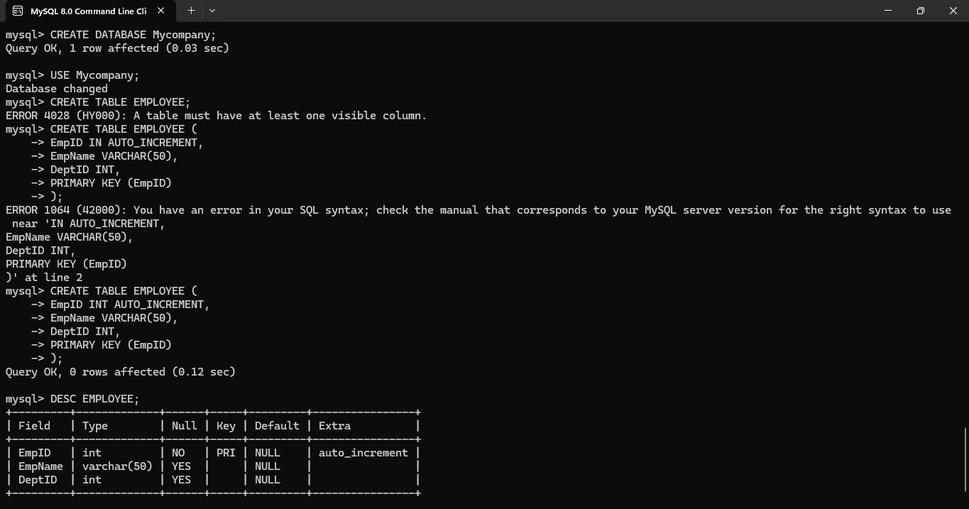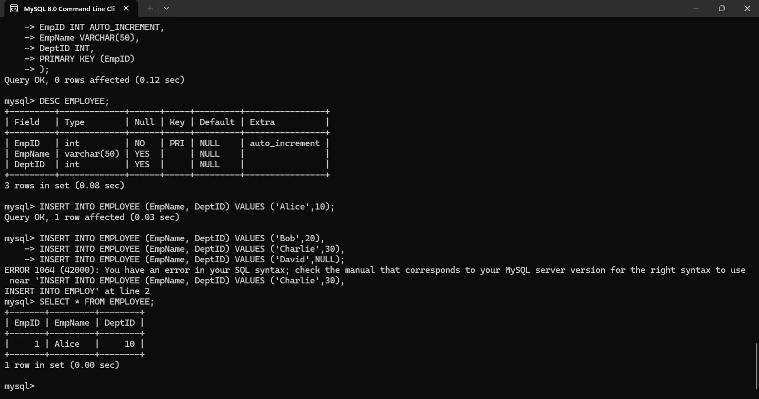

EX. No. 14 – Simple Programming using REPEAT and WHILE

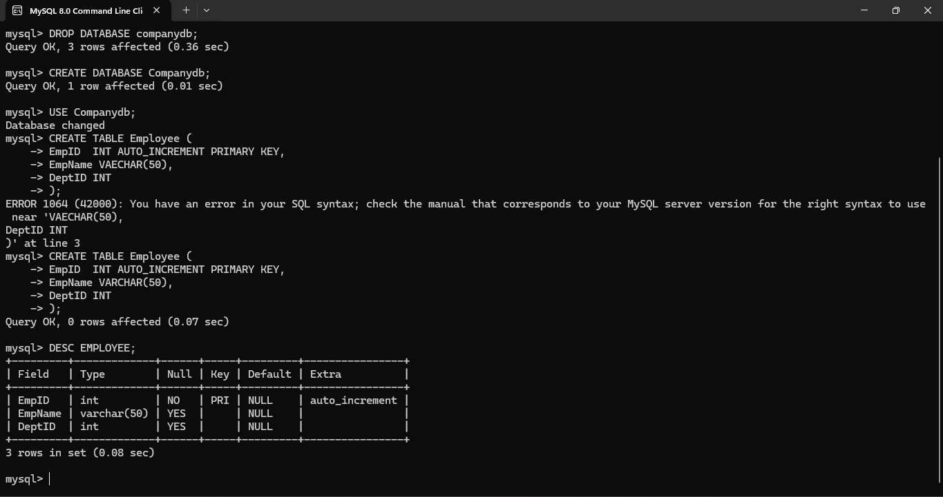

EX. No. 15 – Simple Programming using CASE and LOOP

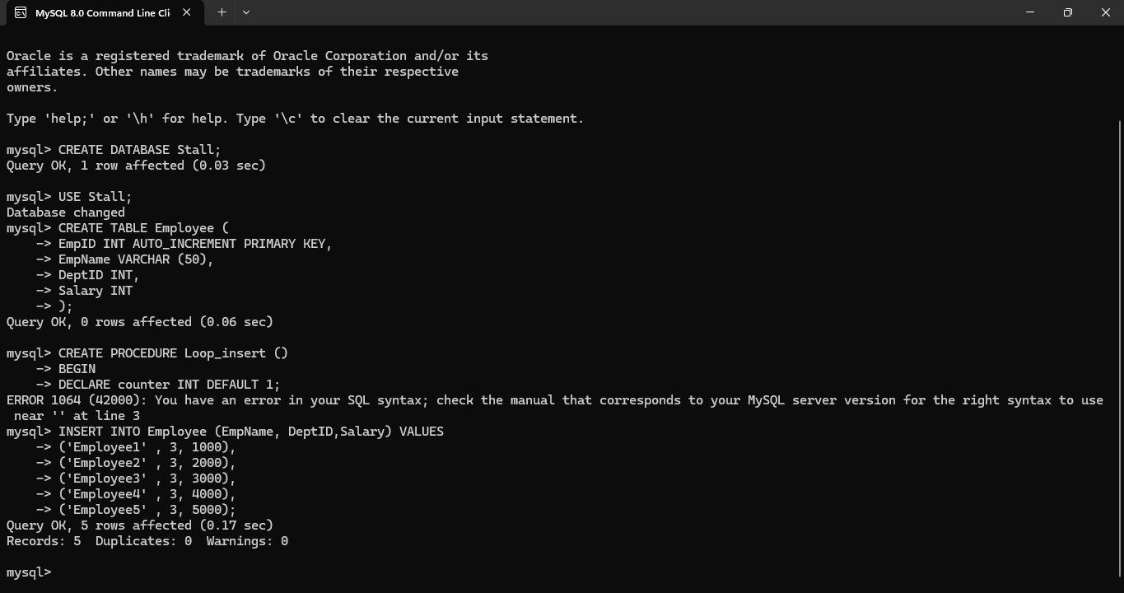

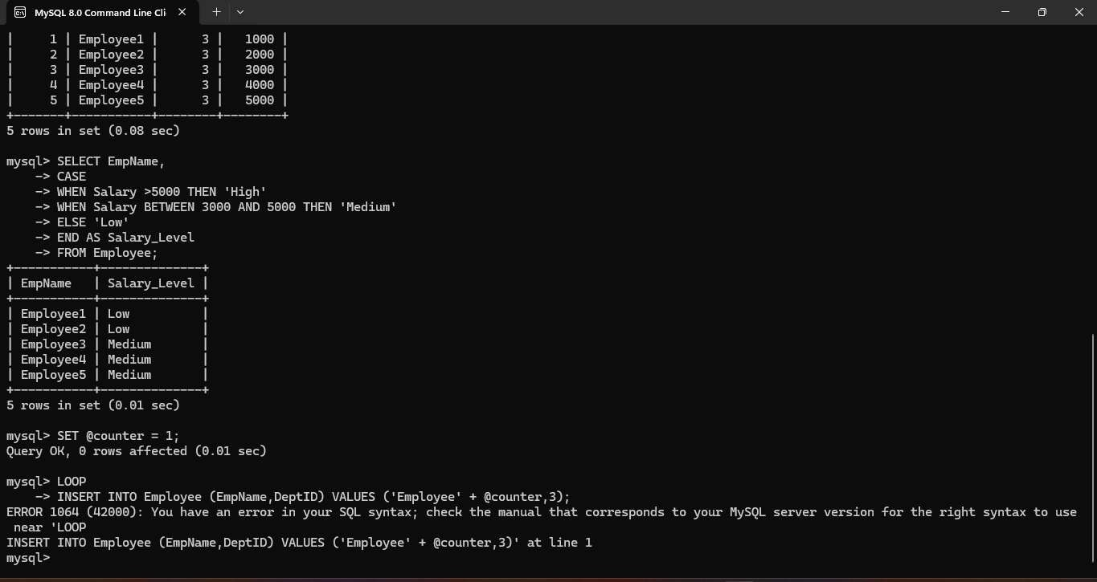

EX. No. 16 – High-Level Programming Extensions – Procedures

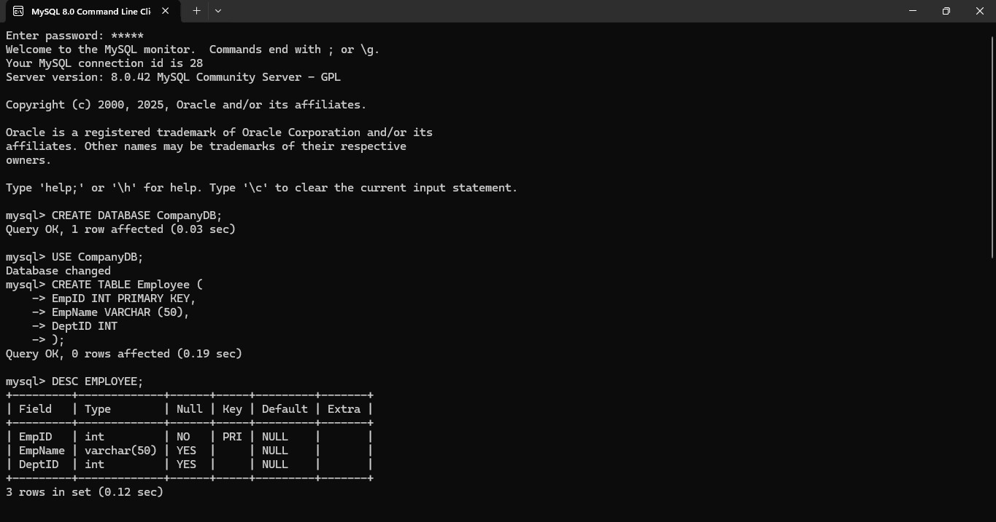

EX. No. 17 – High-Level Programming Extensions – Function

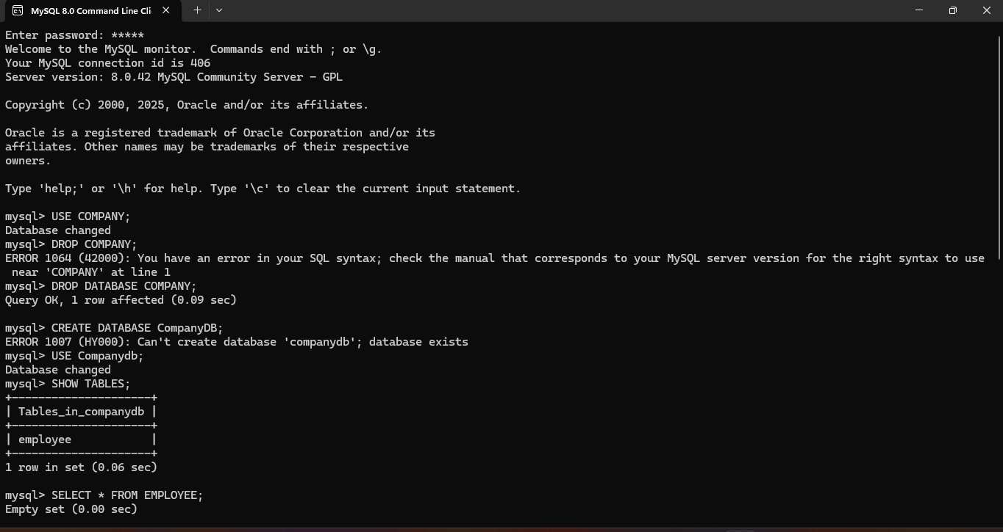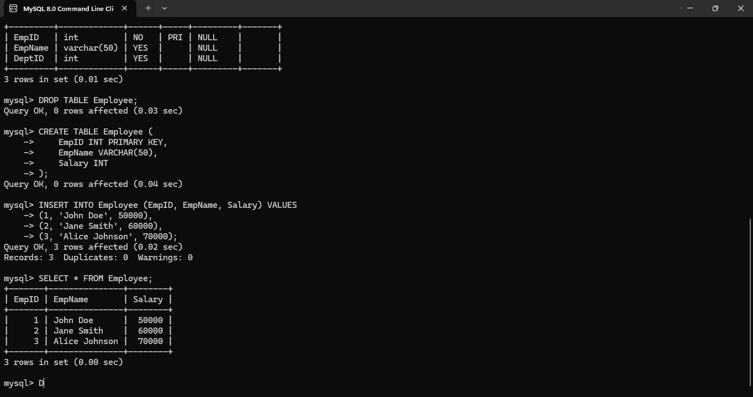

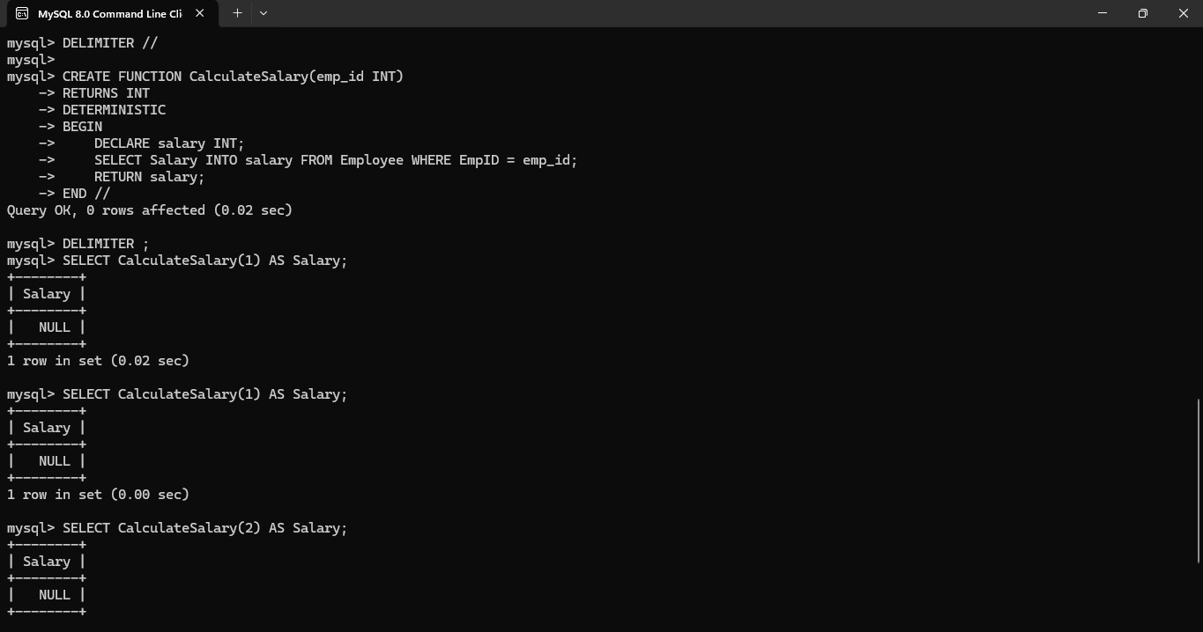

EX. No. 18 – High-Level Programming Extensions – Cursors

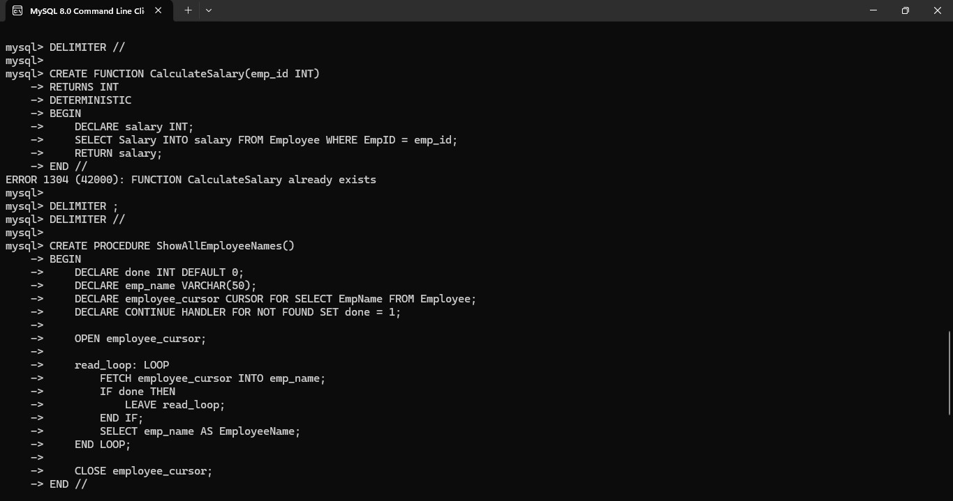

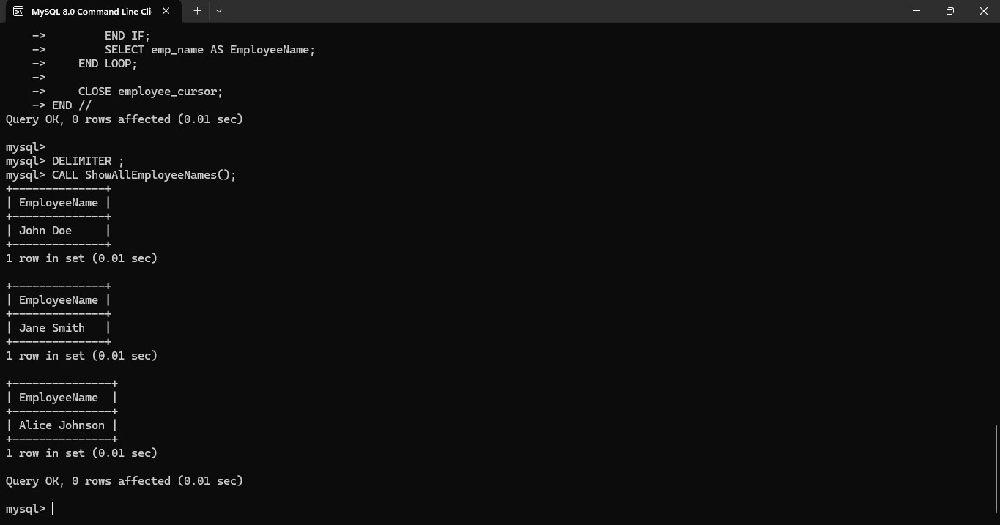

EX. No. 19 – High-Level Programming Extensions – Triggers

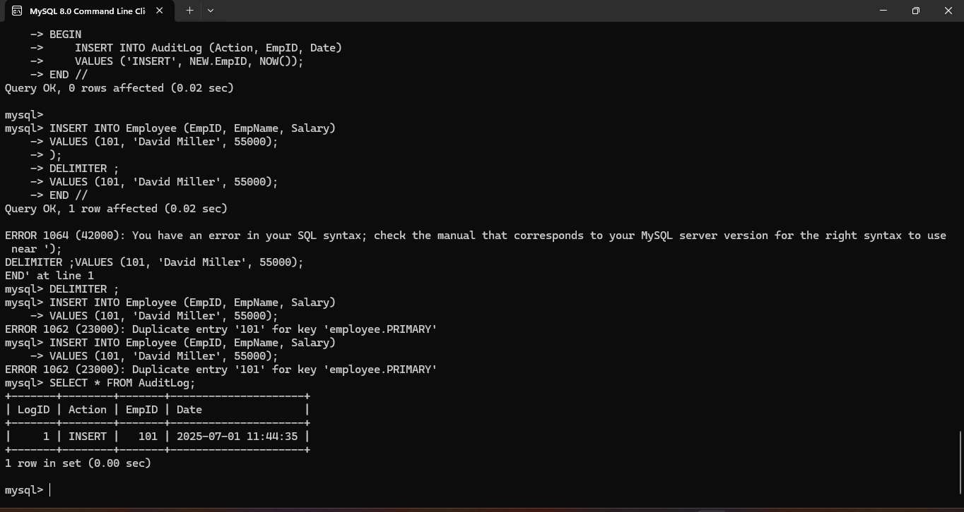

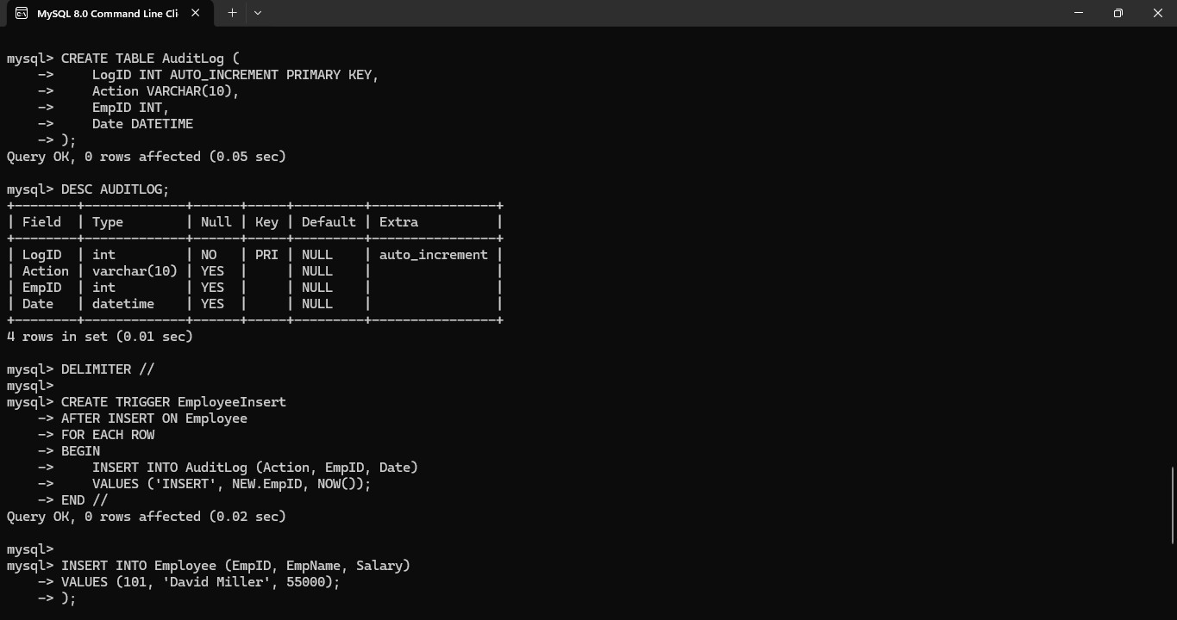

EX. No. 20 – MySQL String Functions – REPLACE, REPEAT, REVERSE, RIGHT, LEFT, RPAD, LPAD

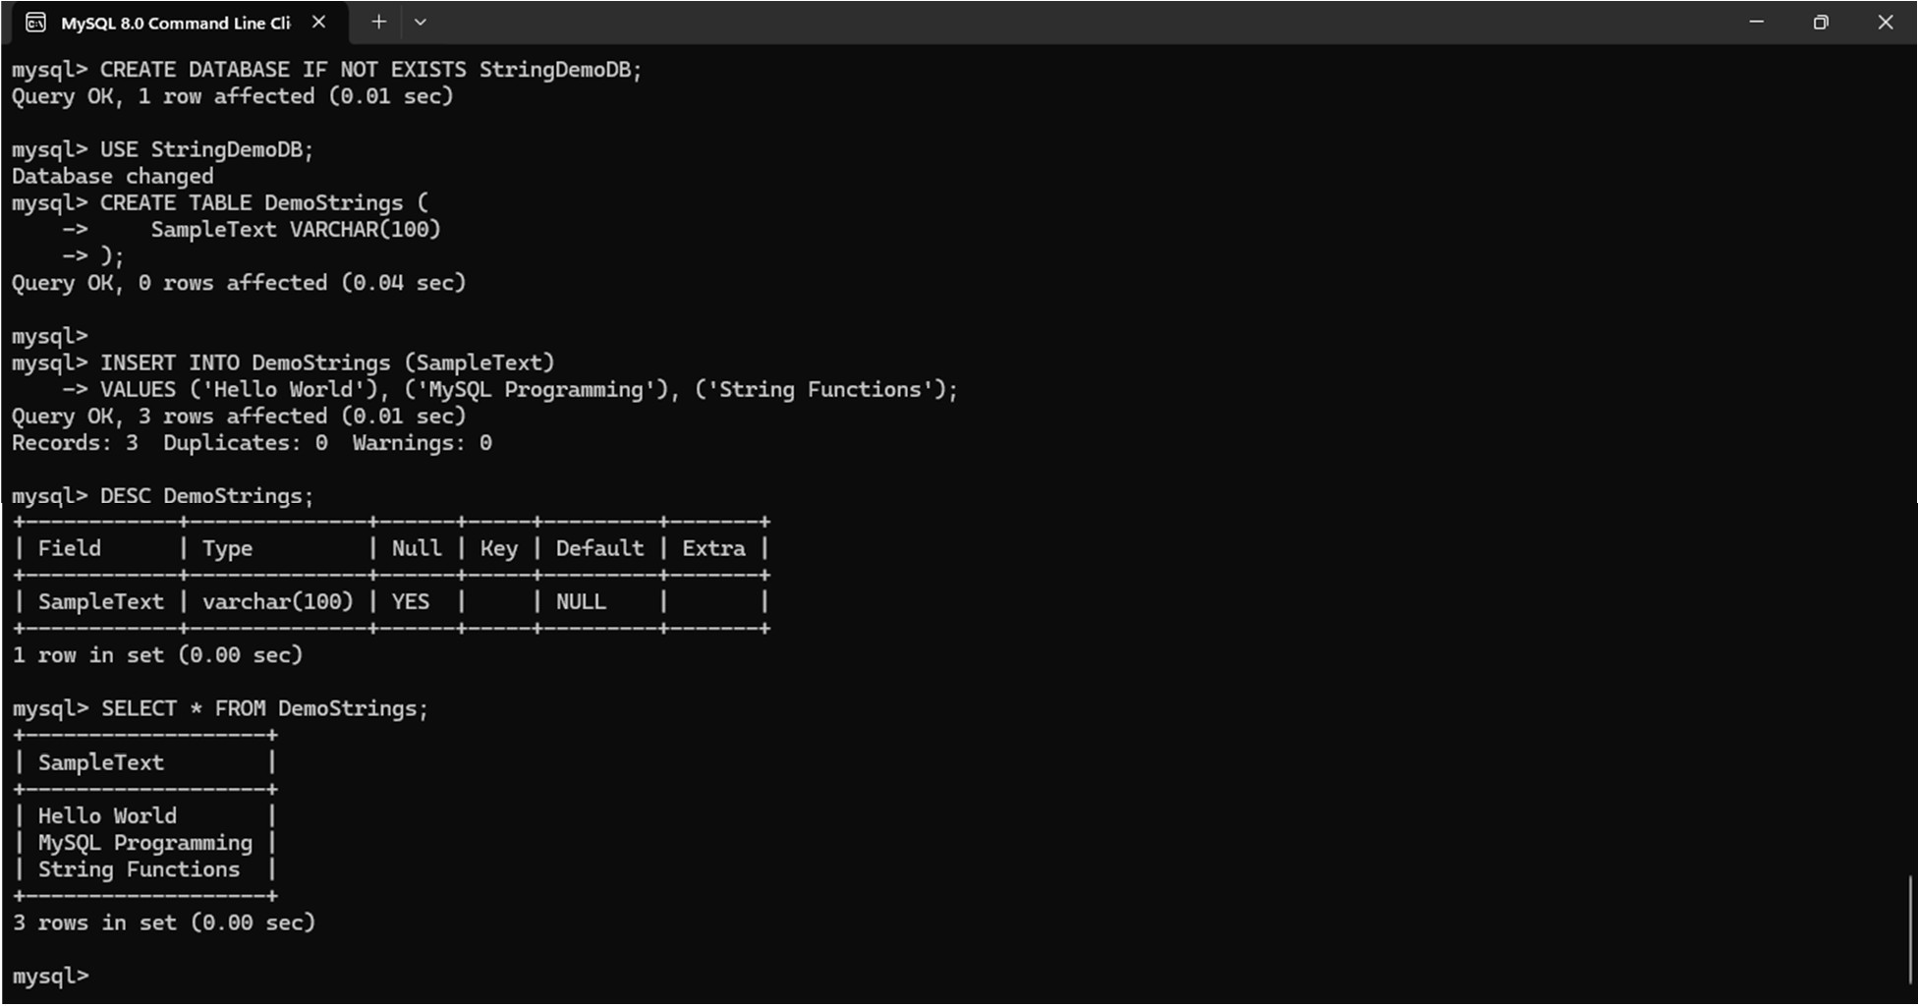

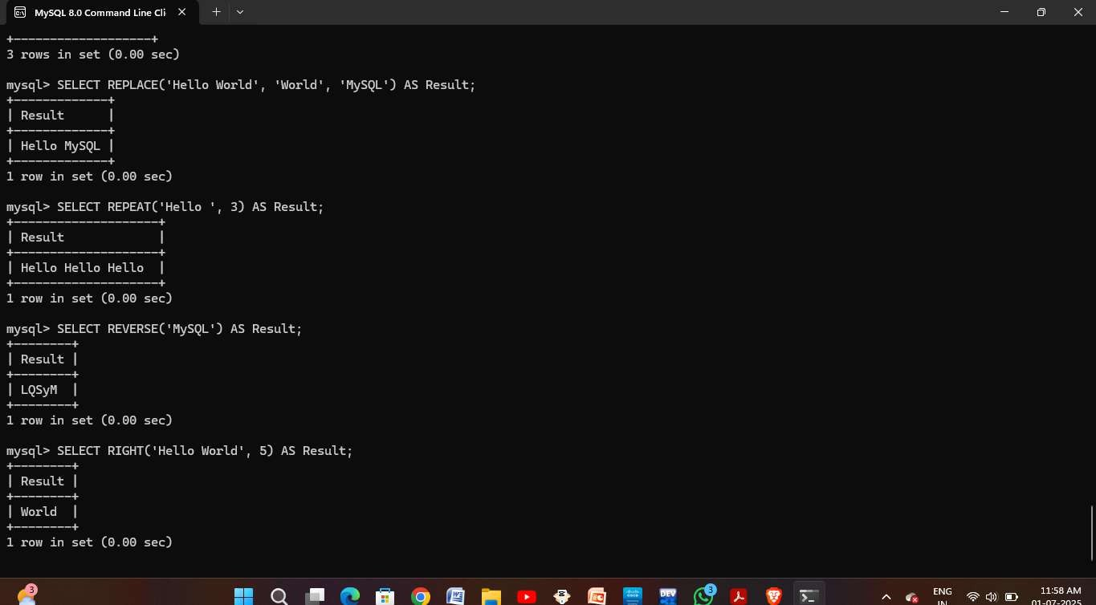

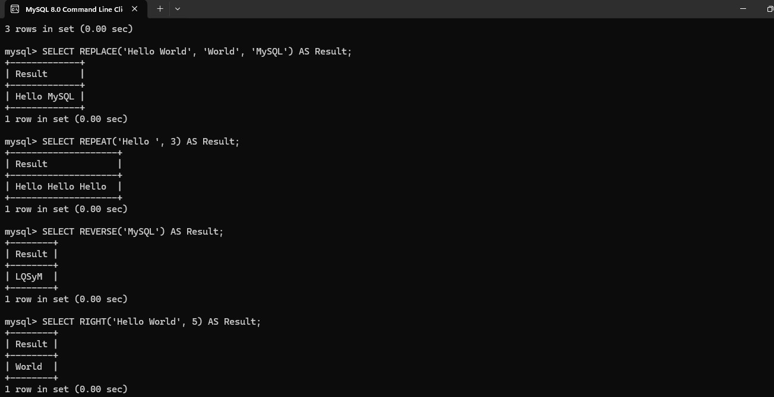

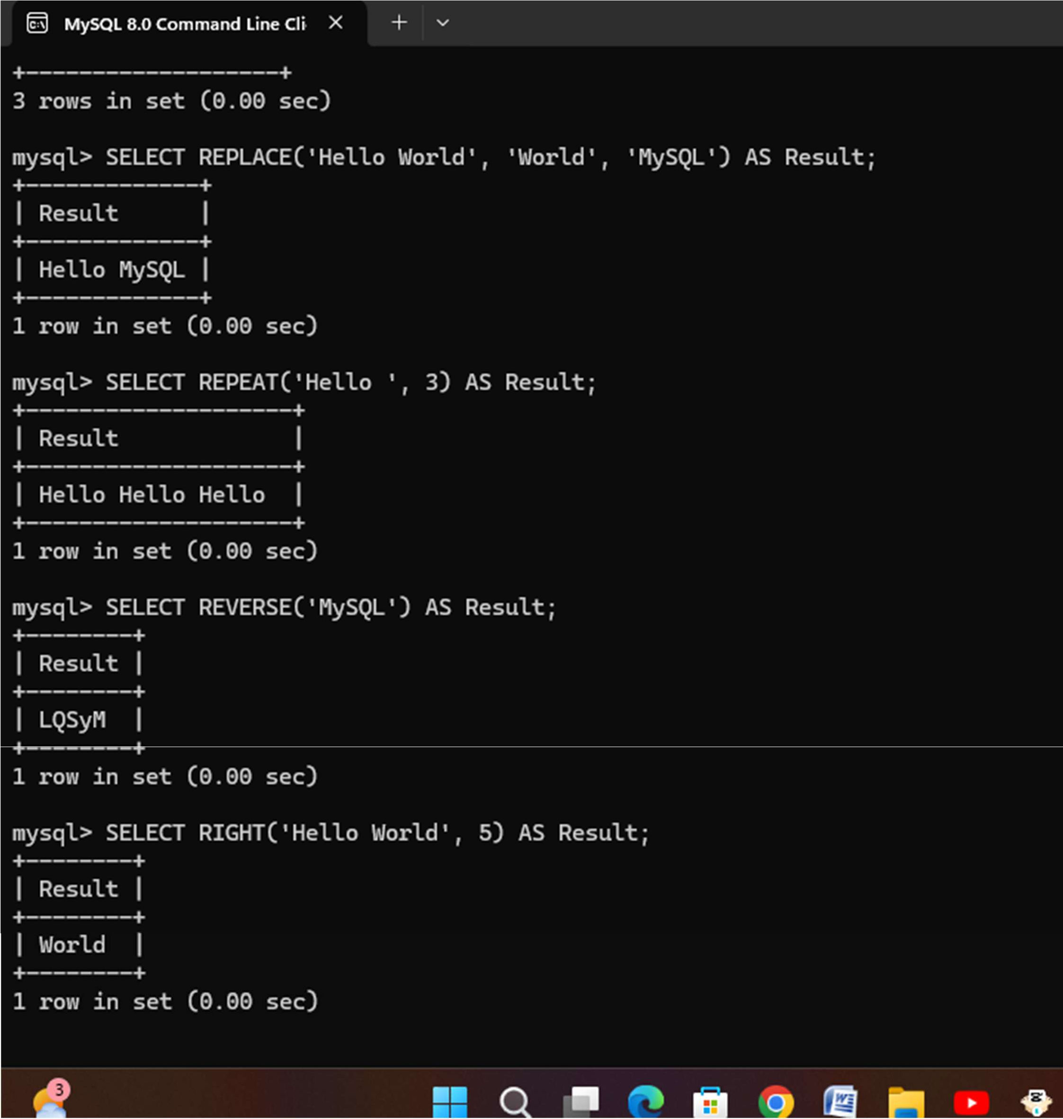

EX. No. 21 – MySQL String Functions – SPACE, SUBSTR, UPPER, LOWER, TRIM, LENGTH

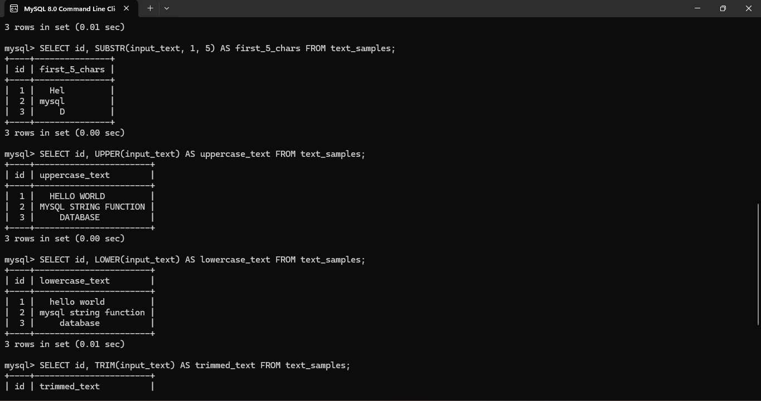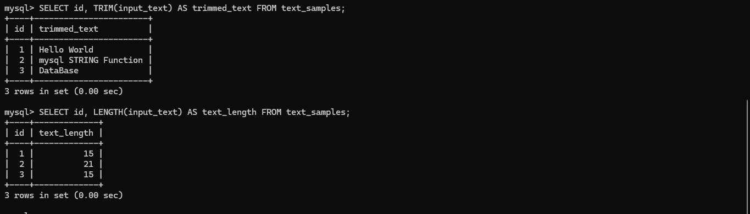

EX. No. 22 – Database Connectivity Using PHP and MySQL

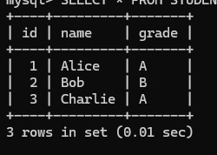

EX. No. 23 – Case Scenario: MySQL Queries Implementation for Train Ticket Reservation System to

Receive Tickets through Social Network

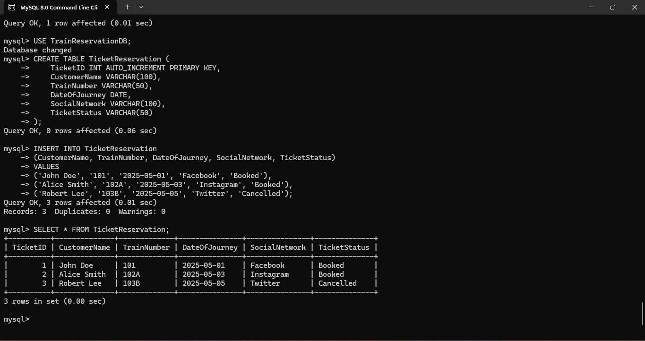

EX. No. 24 – Case Scenario: MySQL Queries Implementation for College Admission Form

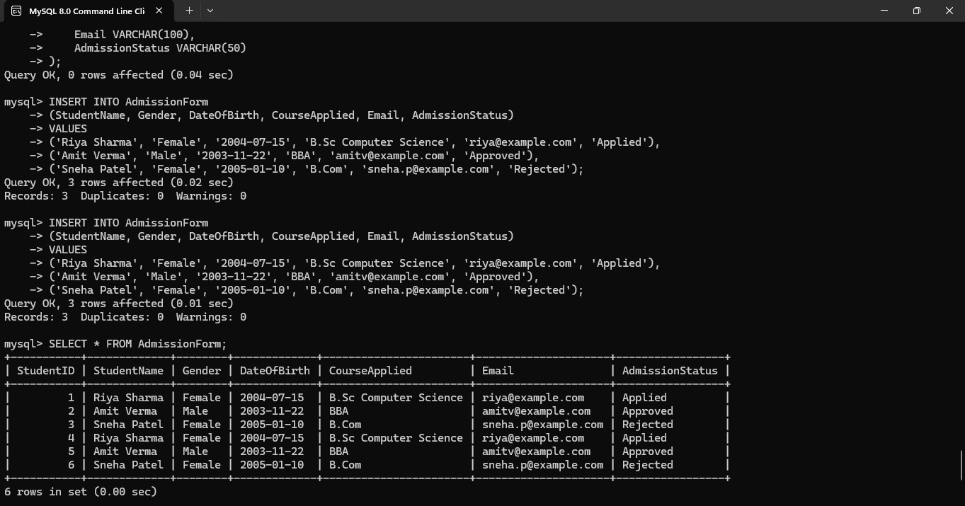

EX. No. 25 – Case Scenario: MySQL Queries Implementation for QR Enabled Automatic Bus Ticket

Booking System

